Werewolf
  - “What to Expect” Information

About Werewolf

Werewolf is an interactive theatre experience.
It is set in a safe house with three wardens. There’s a mysterious threat, and it’s up to the wardens and the audience to stay safe and get through the containment period.
The show has lots of funny and chaotic moments, mixed with spooky, unsettling and scary moments.
The audience helps shape the story, so the play is different every time. (See the “Audience Interaction” section for more information).
Even though this show is interactive, it is still being presented in a theatre style, which means that the performers will be on the stage, and the audience will remain seated for the duration of the show.

Show and Venue Information

This show is 1 hour and 10 minutes long.
Please note: there is a strict lockout policy, meaning that latecomers won’t be allowed into the Theatre.
Werewolf will take place at Q Theatre on 5-7 March at 7pm, and 8 March at 3.30pm.
Q Theatre is located at 305 Queen Street, Auckland 1010.
There are three performance spaces at Q Theatre. These are called: Loft, and Rangatira, and The Vault. We refer to these as “theatres” as well as calling the building as a whole “the theatre”.
Werewolf will be performed in Loft. Loft is located on Level 2 of the building and can be accessed by using the internal stairs or elevator, and also by taking the staired external entry point located to the left of the main entrance on Queen Street.
The Venue is wheelchair accessible. You can learn more about Q Theatre on the website.
Accessibility information is also provided in a pdf document:
https://www.qtheatre.co.nz/sites/default/files/202311/Access%20At%20Q%20PDF_0.pdf.
The outside of Q Theatre seen from Queen Street
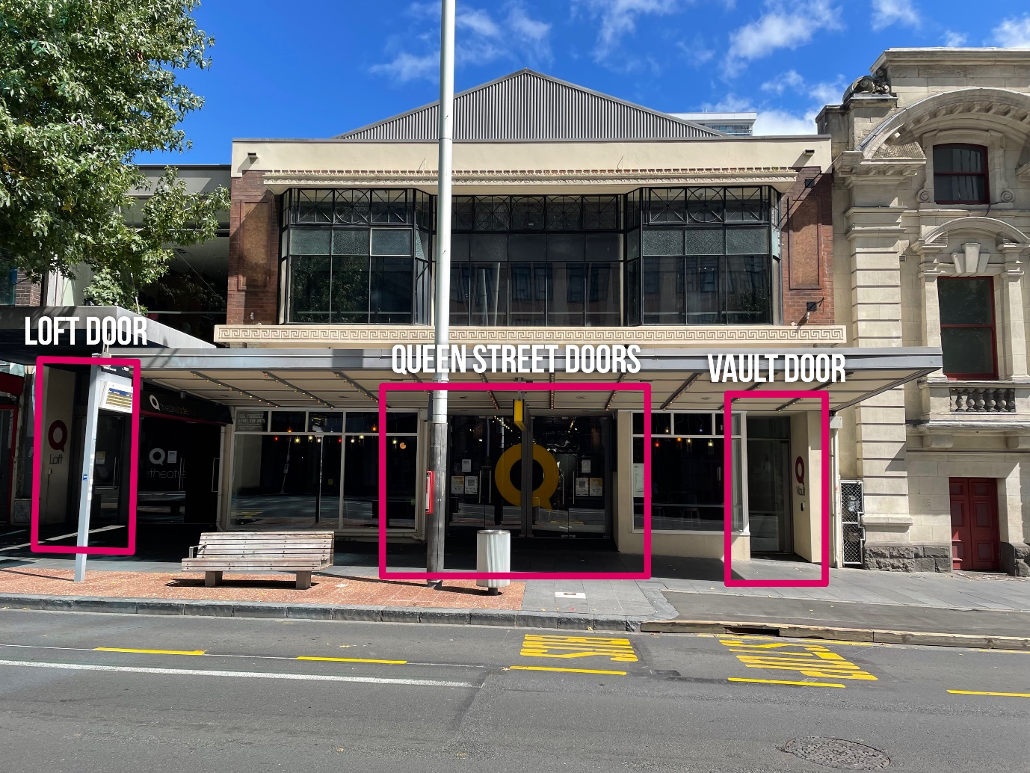

Lighting

Audience Lights
Audience lights will be on for much of the show, except when all the lights in the theatre turn off.

Complete Darkness
The show contains seven periods of extended darkness (blackout). The first of these lasts only one minute long, the rest are longer with a maximum length of 5 minutes.
- There is a gradual fade into lights out to start with the first sequence of lights out, so the audience can see this coming
- During the first sequence torches and the screen will remain on
- During the second sequence, Joel is fumbling with the torch and screen is on
- From the third sequence onward, torches will be off and the screen may also turn off, and it can be really dark

Here is a photo taken during one of the periods of darkness, when there are still some lights on. (It will get darker than this when all lights are out.)
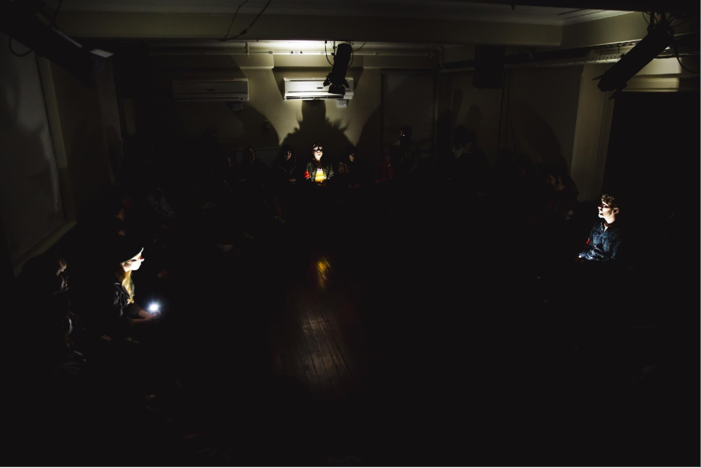
Audience members are encouraged to close their eyes if feeling uncomfortable during the periods of complete darkness, as this may help with feeling more in control.

Bright and Flashing Lights
- White lights are shining toward the audience and may be bright
- The reflective silver background will shimmer and reflect light
- During lights out at the end of day 4, there’s a sudden flash of red light designed to startle the audience
- The lighting at the end is slow, sudden and bright flashes; not quite strobe lights, until a slight flicker at the end.
- There are bright flashes (almost like a huge camera flash) until a short strobing sequence

Sound
Loud, Sudden Noises
The show has a surround sound design that includes several loud, sudden noises and a generally spooky and dramatic background soundscape including sounds effects such as:
- a plane overhead, a loud heartbeat, bones breaking, and an axe smashing a door
- There’s a very loud sound during the second lights out designed to startle the audience

Audience noises
- The audience may get noisy, and they may scream, laugh, chant and react loudly at any moments during the show.

Audience Interaction
Audience Participation
Every audience member will be given a card with a short instruction on it which they are to complete during the show. All cards are designed to be easy to follow.
If you wish, you can request not to have a card, but participation is highly encouraged.
For example a card may say something like:
INVENTORY MONITOR
On day two, help the wardens check the medical kit.
Make sure everything is accounted for.
It will be clear in the context of the show what your card means and when you are supposed to complete the action described on it.
There may also be some moments of group audience participation, and we may ask the audience to talk to each other.
On the next page, you’ll find a photo of what that might look like.
This photo shows one moment of group audience participation.
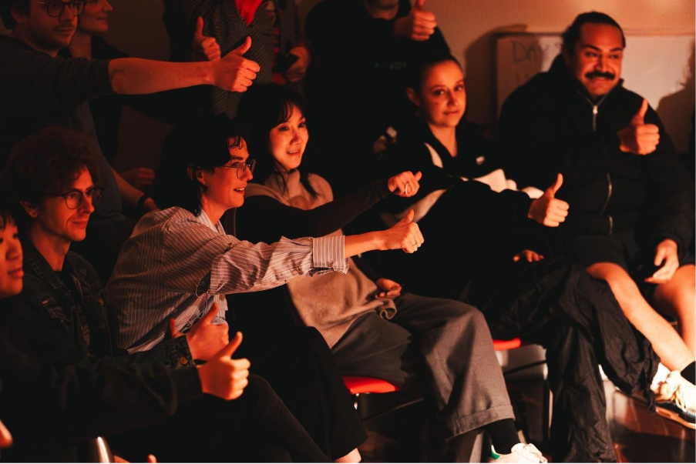
For Werewolf, as well as the seating block, there will be eight audience seats on the stage. The people who sit in one of the eight seats on the stage may be asked to move around. You can decline if asked by one of the Wardens if you would like to sit in these seats.

The audience members in the regular seating block will not be asked to move. If you are not comfortable walking around, we recommend sitting in the seating block, rather than in one of the seats on the stage.

Cast Interaction
Some of the cast will be acting as Wardens during the show. They will be wearing orange armbands.
These actors will interact with you throughout.
They will come into the aisles and the audience regularly. They will remain “in character” which means that they will act like a Warden at all times, no matter what happens.

Audience Interaction
During this show, you are allowed to talk and make noise, providing you are respectful of what it happening on stage. For example, if the cast are talking, please keep your voice low so that other audience members can hear what’s being said on stage.
Please do not touch the cast members.

Content warnings
Coarse Language – There is mild swearing in this show.
Depictions of Violence – This show involves a fight sequence involving an axe. This is carefully planned and choreographed between two actors.
Content Designed to Unsettle – The show will be funny at times and creepy/spooky at others.
Some of the content is designed to feel unsettling.
If any of this content is distressing to you, you’re welcome to close your eyes, cover your ears, or leave the theatre.
Please note, if you do leave the theatre, you will not be able to go back in.

Help during the performance
If you need urgent help during a black out, please raise your hand straight up. The Stage Manager will be monitoring the show via camera and can come in to assist you.
Please feel free to approach staff members at any time if you need help.

Leaving the theatre
You are welcome to leave the theatre during the performance if you need to.
If you do so, please move carefully but promptly to the aisle to avoid blocking other people’s view.
Audience members are encouraged to wait until the lights come back on, as it will be very dark during the blackouts and it may be difficult to find your way. The exit signs are not visible during blackout periods unless there is an emergency.

Cast members may respond to you leaving in character to support you leaving gracefully.

If preferred, seats can be reserved near the door for people who think they may need to leave the theatre. You can also ask the cast as their Warden characters to seat you near an exit.

Please note, if you do leave the theatre, you will not be able to go back in.

At the end of the show, there will be a blackout and music, then bows from the performers as the audience claps. The lights will come back up so you can see to leave the theatre. You are welcome to stay and chat or have a drink in the bar or foyer after the show.

Want to know more?
If you have any questions please contact the Auckland Arts Festival Accessibility Coordinator Hannah:
E-mail access@aaf.co.nz
Phone/text: 022 1239 759

